**Subscribers galore exploring world’s top YouTube channels**

**Submitted by,**

M.Yuvasri. 2113391083124

P.Priyanka. 2113391083107

P.Vasanthi. 2113391083122

T.Thamizharasi. 2113391083120

**1.INTRODUTION:**

Keep in mind that YouTube’s landscape is ever-evolving, and new channels may have risen to prominence since my last update. You can explore these channels on YouTube to discover their latest content and check their current subscriber counts.

**1.1.OVERVIEW:**

As of my last knowledge update in September 2021, I can provide you with an overview of some of the top YouTube channels. Please keep in mind that YouTube ranking can change rapidly due to shifts in viewership and subscriptions. For the most current information, consider checking you tuber’s official statistics or third-party tracking websites.

**1.2.PURPOSE:**

The top YouTube channels serve various purposes and cater to a wide range of audiences. Here are some common purposes of the world's top YouTube channels.

These are just a few examples of the diverse purposes that top YouTube channels serve. YouTube has become a platform where creators can share their passions, expertise, and creativity with a global audience, making it a versatile medium for various forms of content.

**2.PROBLEM DEFINING & DESIGN THINKING:**

Defining a problem and applying design thinking to address it can be a valuable approach for YouTube channels looking to improve or grow their content and audience. Here's how you can apply problem definition and design thinking to top YouTube channels. By following these steps and maintaining a user-centric approach, YouTube channels can address problems, enhance their content, and better connect with their target audience, ultimately leading to growth and success.

**2.1.EMPATHY MAP**:

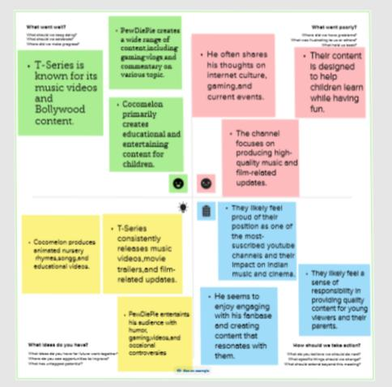

**2.2.BRAINSTROMING:**

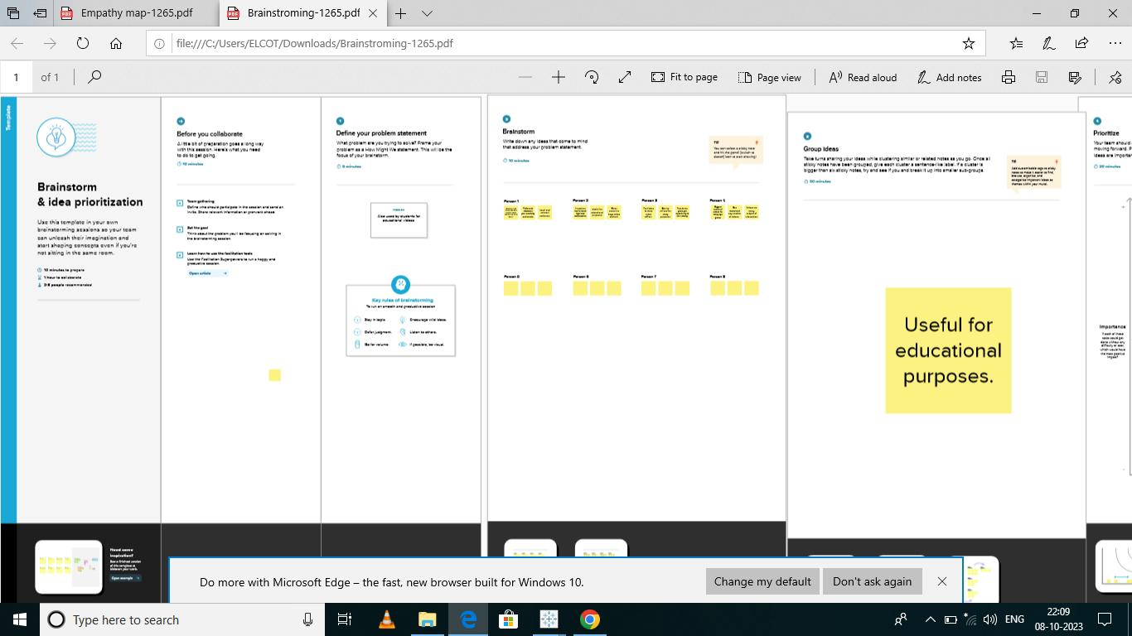

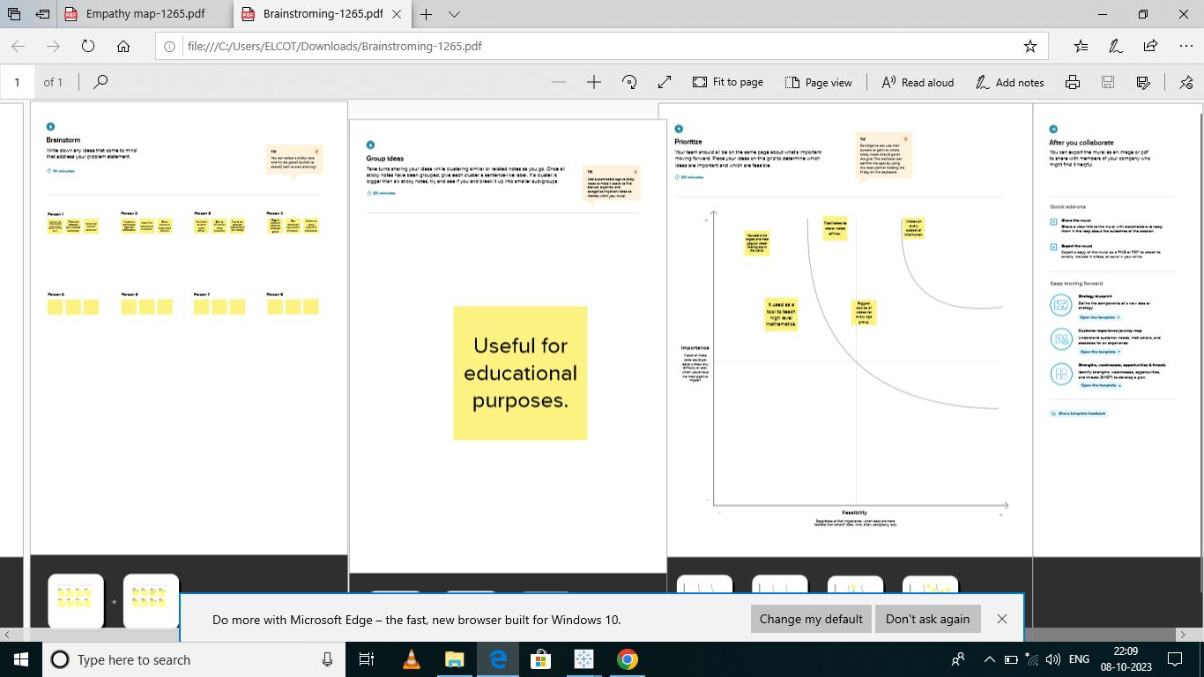

**3.RESULTS:**

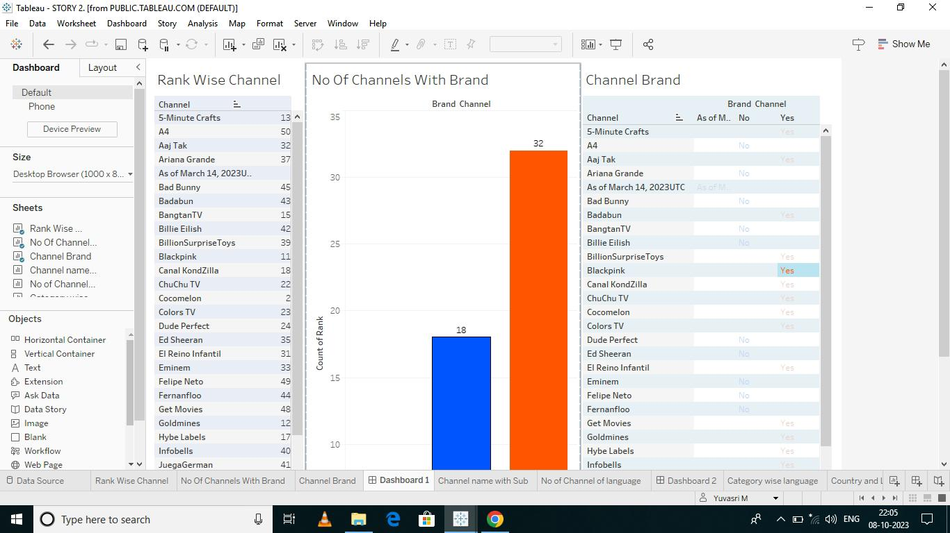

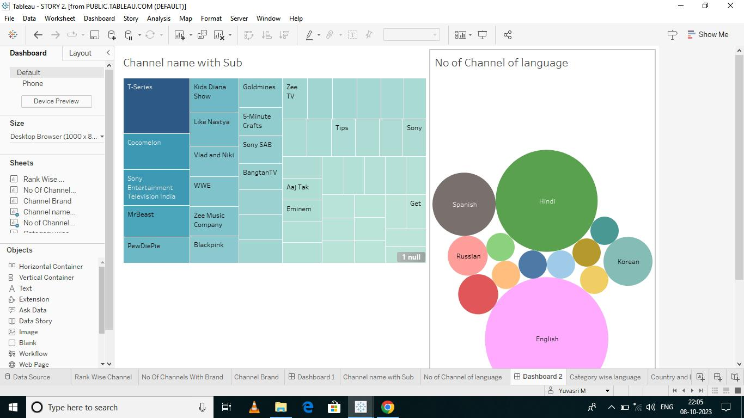

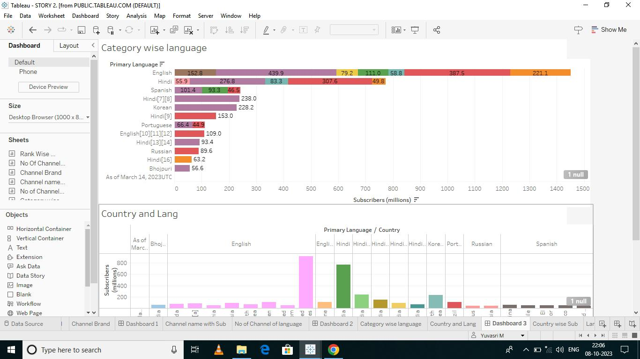

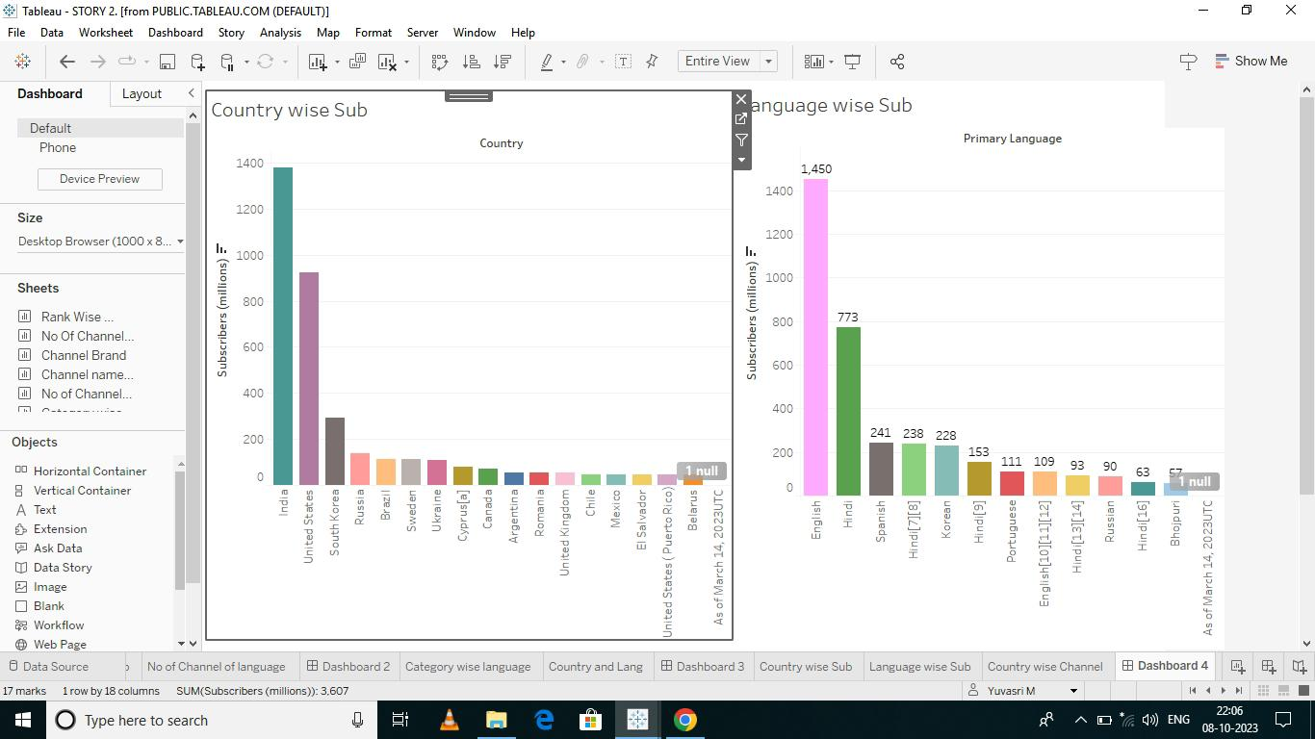

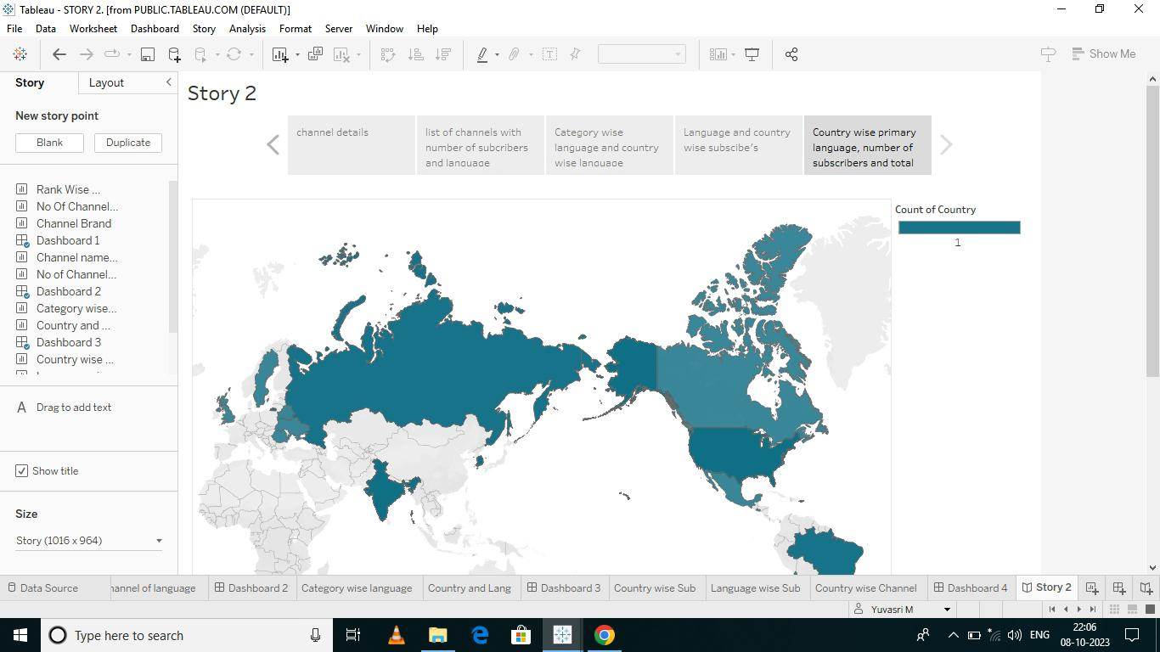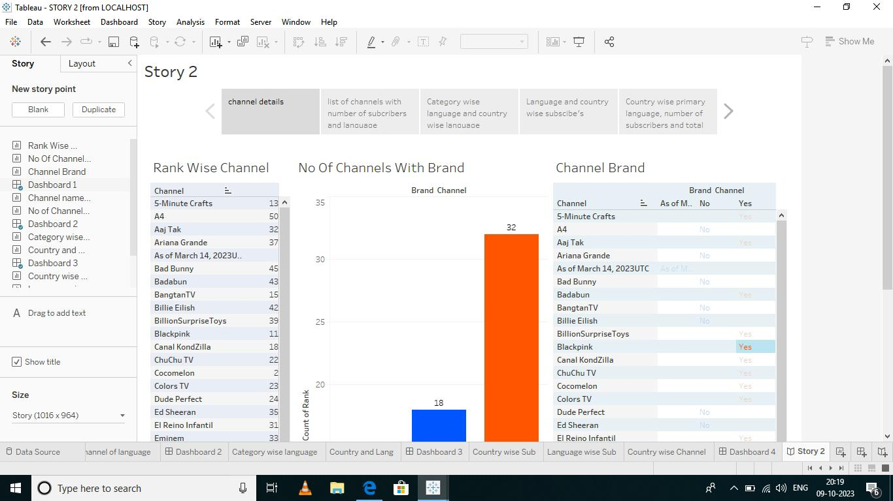

**4.1.ADVANTAGES:**

* Top YouTube channels often have millions or even billions of subscribers and viewers, allowing them to reach a global audience and have a significant impact.
* Popular channels can generate substantial income through ads, sponsorships, merchandise sales, and fan contributions, making YouTube a lucrative platform for content creators.
* They have highly engaged fan bases, which can lead to stronger community
* They can use their platform to raise awareness about important issues, promote social causes, and contribute positively to society.

**4.2.DISADVANTAGES:**

* There is immense pressure to maintain high-quality content and engagement levels. Any decline in performance can lead to a loss of viewership and revenue.
* Personal privacy can become a major concern, as fans and the media may intrude into the creator's personal life, causing stress and discomfort.
* Top channels are often highly dependent on YouTube's algorithms for visibility and recommendations. Changes in these algorithms can impact views and income.

**5.APPLICATION:**

Many top YouTube channels are focused on entertainment. They create content such as vlogs, comedy sketches, music videos, and gaming videos to entertain and engage their audience. Several top channels provide educational content in various fields, including science, technology, cooking, DIY projects, and more. They serve as valuable resources for learning and skill development.

**6.CONCLUSION:**

In conclusion, the world's top YouTube channels have a significant impact on the digital landscape and global culture. They offer a wide range of content, from entertainment and education to advocacy and product promotion. These channels enjoy advantages such as massive reach, monetization opportunities, and creative freedom, but they also face challenges like privacy invasion, burnout, and the need to adapt in a competitive environment.

**7.FUTURE SCOPE:**

The future scope for the world's top YouTube channels will be shaped by technological advancements, shifting audience preferences, and the evolving digital landscape. Adaptability, creativity, and a strong understanding of their audience will be key factors for continued.